In my final project, I am doing a time-space visualization. I am collected weather data from 20 weather stations from the [NOAA](https://www.noaa.gov/) website, pre-process the data, and visualize them based on the location of the stations. The project consists of a series of tasks, starting from data collection and pre-processing up to visualization. Below, I am summarizing the taken steps:

# Data Collection

I collected the weather data from the NOAA website. For that, I prepared an instruction that shows how I selected the stations.

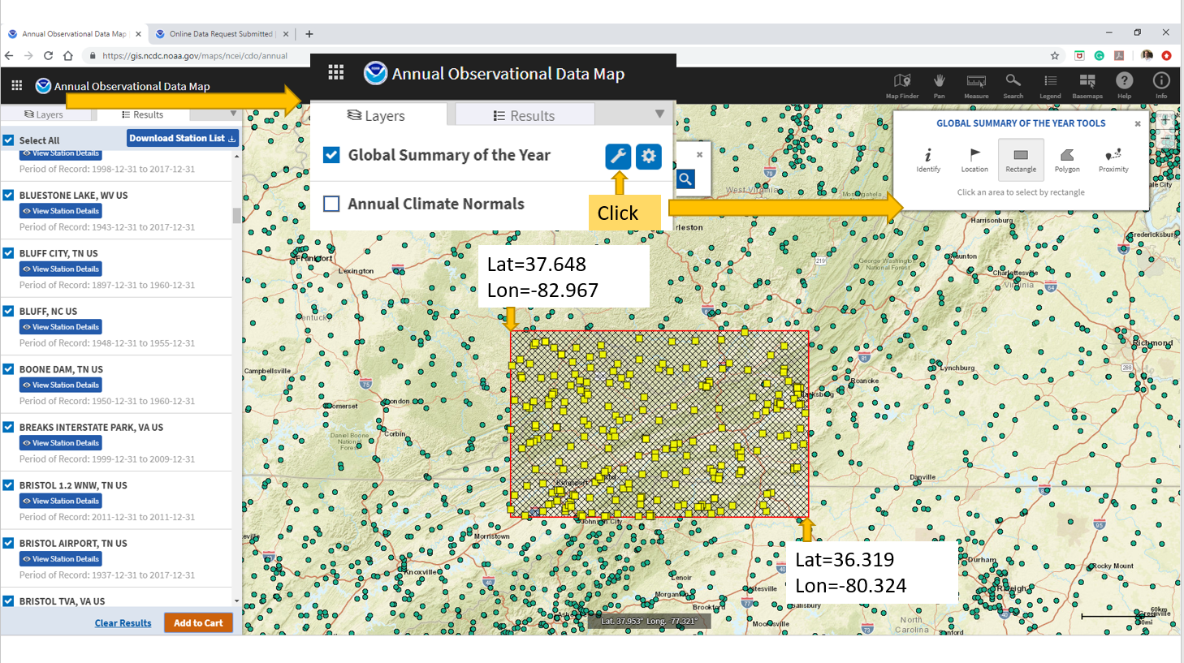

I collected TMAX (maximum temperature recorded in a day), TMIN (minimum temperature recorded in a day), PRECIPITATION (the amount of precipitation recorded in a day), and SNOW (The amount of snow recorded in a day) from the shown weather stations for 5 years (2015 – 2020). Then, I cleaned the dataset and removed the stations that do not have enough records. I cleaned the collected dataset and merged them and created a single dataset to be used in the project.

# Creating a Clean Dataset:

After this, I cleaned the dataset. To this end, I removed any missing information from the dataset and prepared a cleaned dataset to be used in the next steps.

# Scatter Plot for Weather Stations:

I used a scatter plot to visualize the location of the considered weather stations. Because the locations were reported based on latitude and longitude, I had to use a specific transformation to visualize them. To this end, I first transformed the latitude and longitude of all stations into X-UTM and Y-UTM and then visualized them accordingly.

Each station can be selected using a left-click. Upon clicking, the name of the stations will be also rendered on the screen and the color of the sphere also would be changed. This is the very means of interaction with the user.

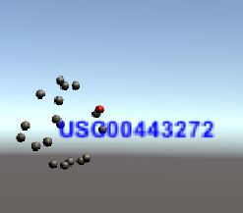

# Scatter Plot for the Year Controller:

Similarly, I used a scatter plot for visualizing the temporal content of the data. Each dot in the scatter plot corresponds to one year of the data. It can be also clicked using the left-click of the mouse. Upon clicking, the color of the sphere would be changed and the name of the year would be also rendered on the page. By default, the year 2020 is selected and users can change that by clicking on another year.

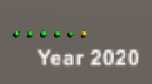

# Bar Chart for Visualizing Data:

As I mentioned, I considered four features (maximum and minimum temperatures, snow, and precipitation). I used a bar chart to visualize the data. I also used multiple text meshes to show the value and the parameter on top of each bar. The only important factor to note here is that because the order of the features was different, I manipulated the data so that they can be rendered next to each other.

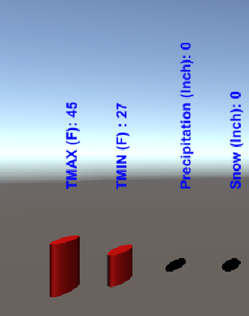

# Interaction

There are multiple ways that users can interact with this dashboard. With a left-click, they can select different stations and different years, one at a time. With a right-click, every clicked item will become unclicked. With scrolling, users can scroll in and out of the page. The arrows on the keyboard also would give users the ability to change the position of the camera in the dashboard.

**IMPORTANT NOTE:**

Implementing this multi-modal interaction was the biggest challenge that I faced in this project. To overcome it, I used multiple tags. Therefore, when running the project, make sure that you have the below tags defined in the project setting:

**“selected”,” year”,”selected-year”,” box”**

# Final Product

Below, multiple snapshots included to should how the app works.

